Tugendhat is decorated by precise work from Laufen located in Znojmo
The door of functional villa Tugendhat in Brno was reopened for public after an extensive reconstruction. A group of top architects set a common goal – a replica with the finest details and maximal spatial authenticity. A famous ceramist from Laufen in Znojmo supervised by Daniel Piršč, an experienced designer, also participated in this challenge.
The whole process of bathroom reconstruction was complicated by the lack of original equipment. Real photos from German archives served as replica models for the washbasin, private period bidet from a restorer in Brno, or a toilet and a double sink from the municipal collection in Brno. „We scanned all material originals and on their bases produced models for molding forms creation. Unfortunately, we could not find the material model for one of the washbasins and so for its creation we used a 3D technology,” explained Piršč, the designer. Experienced professionals from Laufen in Znojmo supervised the completion of the final crafts as well as the whole reconstruction. „We have to thank them for the excellent work,” added Daniel Piršč.
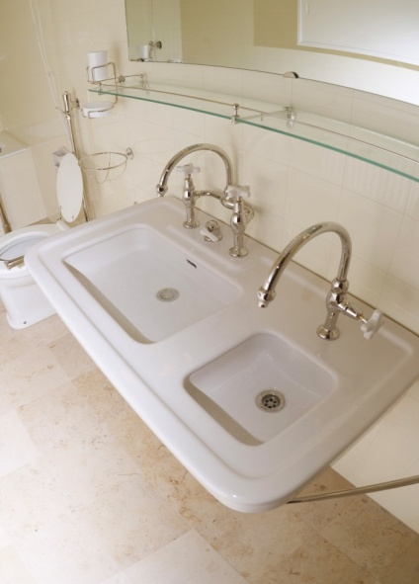
In attempt to preserve maximal authenticity and flawless appearance, we put an emphasis on technological solutions. „For example, it was not easy to coordinate the shade of the enamel in washbasins and bathroom’s facing considering the fact that the color in daily light looks differently than in artificial light,” explains designer Piršč.
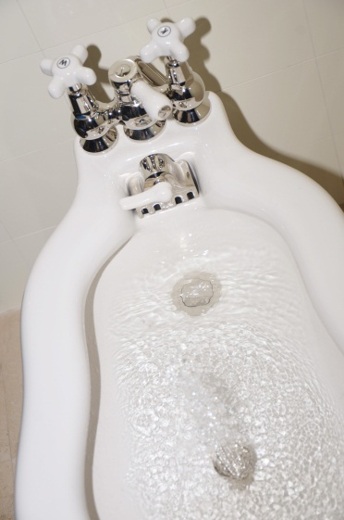
The bathroom equipment in villa Tugendhat matches up to the functional and esthetical requirements of the present day. „It is unbelievable how pleasantly the individual pieces affect humans. They are constantly timeless and in certain sense modern,” adds the designer.
The company Laufen CZ was established in 1999 and represents brands of Laufen, Roca, and Jica not only at the Czech and Slovakian market, but also in other Central and East-European countries. Sanitary ceramics Jika is manufactured in Znojmo and Bechyne. It is an important part of Laufen Swiss concern and since 1999 belongs to a Spanish group of companies, Roca, which is the biggest European producer of sanitary ceramics. Roca was named world number one in 2006. Complete bathrooms belong to the assortment of all production brands – sanitary ceramics (bathroom sets and other products), bathroom furniture, bathtubs and little baths, shower baths, bath screens, faucet and bath accessories.

