Press release

There’s nothing like a hot bath: five tips for choosing the right tub

Prague, 22 February 2017—Furnishing the bathroom ranks among the costliest home investments. Therefore, it really pays to choose each component with care. Great attention should be paid in particular to the bathroom’s centrepiece: the tub. To help you select one that will fit your needs, budget and the layout of your bathroom, we offer five rules to follow when shopping.

Enamel, acrylic or cast iron?
There are bathtubs made of a variety of materials on the market, but by far the greatest demand is for enamelled steel and acrylic tubs. Each material has its specific qualities: durability, resistance to damage, permanence of form, maintenance demands and insulation properties. Of course, these properties are reflected in the price. “The advantages of enamel bathtubs are a lower purchase price and relatively high scratch resistance. Due to the manufacturing process, this category has a limited range of shapes and sizes. Conversely, acrylic bathtubs are available in countless shapes and sizes able to fit into almost any space. Acrylic bathtubs are warmer and pleasant to the touch, but the material is a little softer, which makes the tub more susceptible to damage”, says Miloslav Felkl, product manager of the JIKA brand, adding: “It is worth taking note of cast-iron bathtubs, whose popularity increases every year. The evergreen in this category is the freestanding retro bathtub on legs. Apart from its very attractive design, cast-iron tubs have one indisputable advantage: they keep the water warm for a long time”.

The trend towards composite materials
Bathtubs made of composite materials (a mix of two materials with different properties) are pleasantly warm to the touch and have great insulating qualities. “This makes for a very stable bathtub that is very endurable. Like acrylic bathtubs, those made of composite materials are available in a wide array of shapes and sizes. Examples are the attractive bathtubs in Laufen’s Palomba, Alessi One, Kartell, Val and Ino collections”, adds Felkl.

Cast-iron bathtubs
+ attractive design, can be free standing
+ long service life
+ excellent insulating properties
- heavy, difficult to move

Acrylic bathtubs
+ wide array of shapes and sizes
+ long service life
+ good insulating properties
+ warmer to the touch
- susceptibility to scratching
Enamelled bathtubs
+ agreeable price
+ scratch resistance
- poor insulating properties
- poor sound absorption
- limited shape and size selection

Bathtub of composite materials
+ wide array of shapes and sizes
+ long service life
+ good insulating properties
+ warmer to the touch
- heavy

Classic or asymmetric?
When choosing a bathtub, one of the most important questions is the size of the bathroom where the tub will be installed. The main advantage of asymmetric bathtubs is that they can be used in smaller or atypical spaces. “We recommend consulting with an expert, who will propose workable solutions so that the bathtub doesn’t occupy too much space but still is roomy enough for pleasant relaxation”, says Felkl. He continues: “There is a trend towards ergonomically shaped tubs, which offer comfort in the form of lumbar support. With corner bathtubs, an inner seat is very nice, not just for relaxation but also as a surface for placing things. I generally recommend to choose a bathtub not by appearance but by functionality. The trendiest designer baths are often very uncomfortable”. Always a safe bet are classic rectangular bathtubs. When selecting one, look for the widest bottom surface, which will provide comfort when showering.

The shower compromise
When considering whether to install a bathtub or shower in a smaller space, you can solve the dilemma with the addition of a bath screen. They are elegant, practical and allow for comfortable showering. “A screen can be installed on any bathtub, including corner tubs. When shopping for one, pay attention to its size to ensure that it’s ideally matched to your height”, recommends Felkl.

Filling the tub
The pleasure of bathing depends not only on the shape and material of the tub, but also on the location of the water supply. The deciding factors are functionality and safety. “For example, if you and your partner like to indulge baths together, a wall faucet is most practical, installed above the centre of the tub so that it doesn’t press into anyone’s back or otherwise obstruct. If you have small children at home who move around a lot in the bath, an ideal solution is overflow filling. It’s a modern and very effective gadget that eliminates the obstruction of a faucet and thereby the possibility of incurring injury from it”, adds Felkl.

No slipping in the bath
Bathroom accessories, whether their purpose is safety or increased comfort, are undoubtedly a good investment. Especially anti-slip devices. “Anti-slip treatment is especially suited to families with small children or seniors. It can be sanded directly into the surface of the tub or can be added in the form of adhesive strips. These, however, can become damaged or loosen”, Felkl concludes.

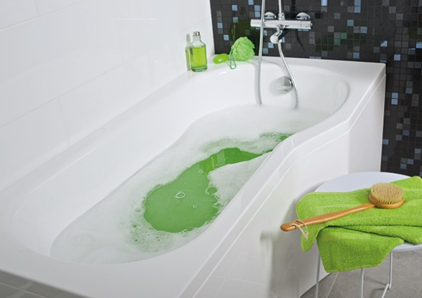

Corner and ergonomically shaped bathtubs offer comfort in the form of lumbar support. They guarantee excellent rest and relaxation.
Photo: JIKA’s TIGO series.

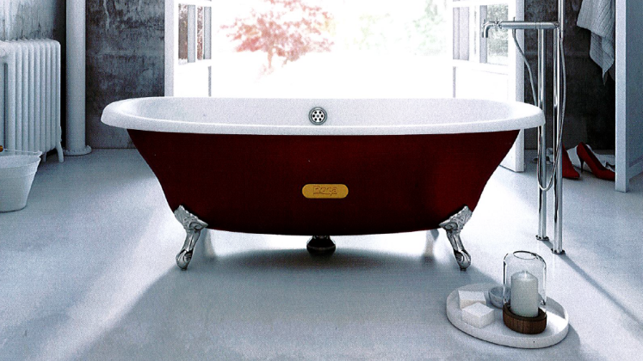

Evergreen among cast-iron bathtubs
are freestanding retro baths with legs.
Photo: ROCA’s Newcast series.

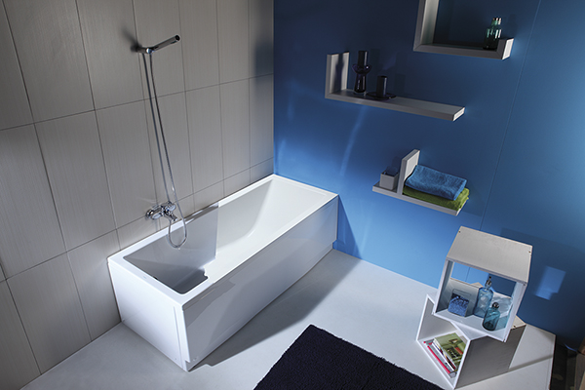

JIKA’s best-selling acrylic bathtub.
Photo: JIKA’s Cubito series.

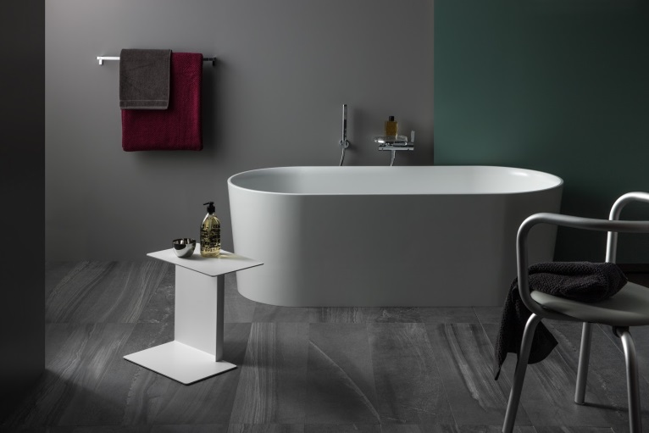

A thin-walled bathtub from the LAUFEN brand made from the material SaphirKemarik.
Photo: Laufen’s Ino and Val series.

