Press release

Children’s bathrooms: a kingdom of colour

Prague, 26 April 2017 – Design for your children a bathroom tailored specifically to their needs. The JIKA brand offers the Baby Set – bathroom furnishings sized for little ones, including sinks, wash basins and free-standing toilets complete with a duroplast seat with no lid. With the Baby Set, you can create a bathroom your children will love. And to make their time in the bathroom even more enjoyable, don’t forget to enliven the walls and floors with cheerful colourful tiles.

In the JIKA brand Baby Set, there are on offer two children’s toilets with a height of 35 centimetres, corresponding to the needs of young children. “A children’s toilet is very practical, not only in preschools, but also in households. The tailored toilet height ensures that children can use the toilet without assistance and there is no risk of contamination around the toilet bowl, which mothers will especially appreciate”, says Alena Machátová, product manager for the JIKA brand. “If you are planning a reconstruction, you will certainly be pleased that our Baby Set has a plastic wall-mounted tank. This eliminates the complications of incorporating a concealed module into the wall”, she adds. The Baby Set also includes small sinks
and washbasins, which are simple to install at the appropriate height for individual children. Another practical idea is a large double sink, avoiding siblings pushing each other at the sink. The whole set is connected by the motif of a katydid, which appears both on sinks and toilet tanks.

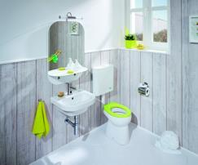
Bright colours

The JIKA Baby Set’s lidless toilet seat can be harmonized with other bathroom accessories to make the children’s bathroom literally radiate with colour. Available in white, pink and green.

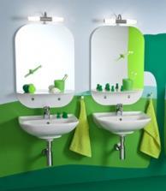
Not just for little dandies

Even young children often want to check their appearance. You can customize mirrors to their needs. A lighted mirror with a shelf from the series Deep by JIKA is an ideal solution. The shelf is decorated with decals in the shape of eyes to cover the mounting, and will also make children smile every time they brush their teeth.

A bathroom where colours can play

In addition to practical bathroom furnishings for children, it’s important not to neglect the aesthetic aspect of the bathroom. Forget about boring grey for a children’s bathroom. A good solution is to harmonize several colours to create a cheerful combination. Give the children a bathroom as well thought-out as their bedroom. Spark their creativity, feel for colour and detail. “Zoom tiles are very interesting on the wall. This series offers a choice of seven colours. Besides basic white and beige, there are five glossy vibrant colours. Each is supplemented with a wavy accent tile. In addition, all of them can be combined with the playful, multicoloured Zoom accent tiles or Arty mosaic tiles”, says Radka Konečná, product manager for JIKA brand tiles. She adds: “The product array in this collection is very diverse, and different elements combine very well. You just have to play with the colours a bit and not be afraid to experiment”.
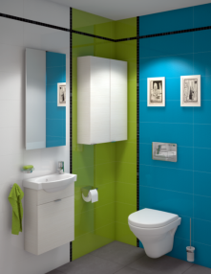
A bathroom in pistachio

If you prefer two-colour combinations, then the best of the best is blue with green. For example, a blue-green combination of Zoom wall tiles in pistachio and aqua. It is just as suitable for an adult bathroom as it is for children.

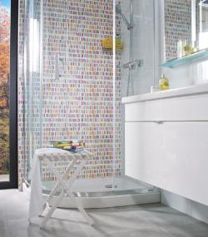
A shower of colour
The playful and colour Zoom accent tile is ideal for shower stalls. The Zoom multicolour accent tile, in a size of, 21.4 x 61 cm. Your children will love it!
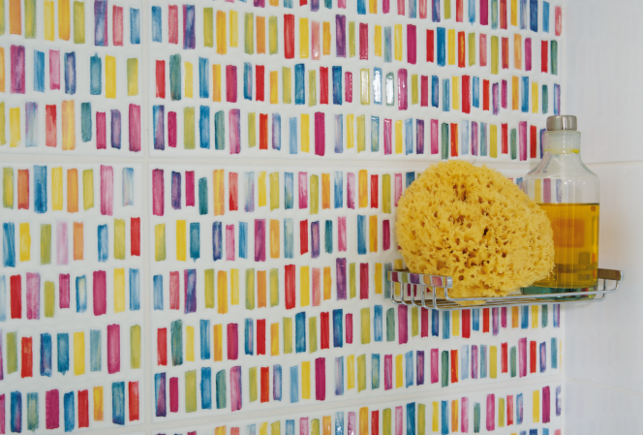

TOP 5 for children’s bathrooms
- Smaller dimensions for our little ones – install in your child’s bathroom a toilet with dimensions matched to their size. Don’t forget about a smaller sink size.
- The right height – the ideal level for mounting a sink is no higher than 60 cm, a toilet no higher than 35 cm.
- Colours – in children’s bathrooms, colour plays a vital role. Spark their creativity and feeling for detail.
- Safety – choose bathroom equipment with a rounded shape rather than ones with sharp edges and corners.
- Durability – look for high-quality bathroom furnishings. In a children’s bathroom, where moisture often fills the air, it’s a smart investment.

